**Terraform Assignment – 5**

You have been asked to:

● Destroy the previous deployments

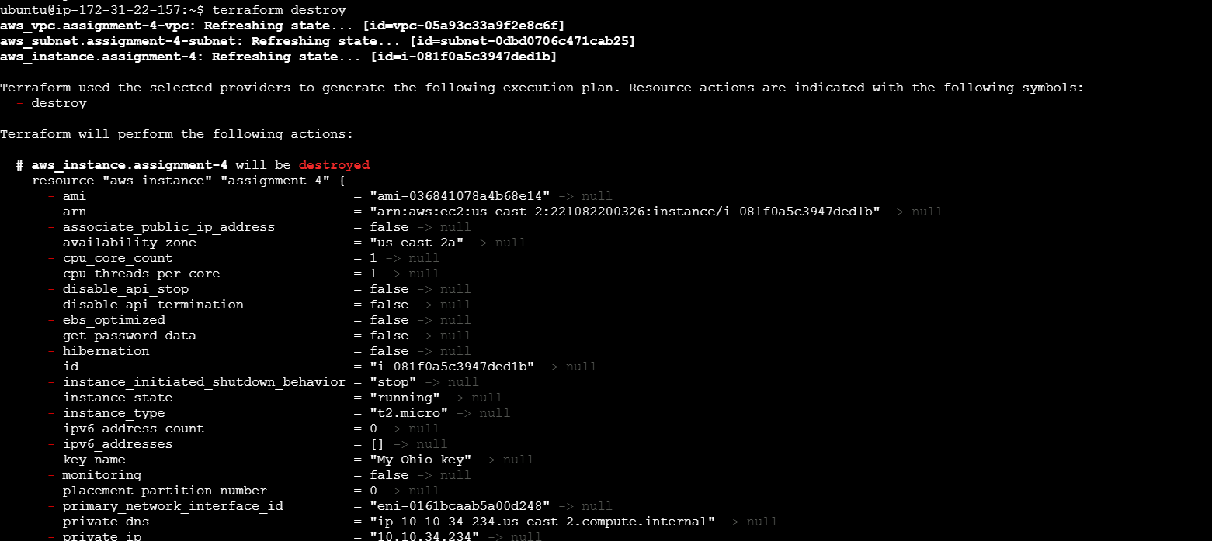

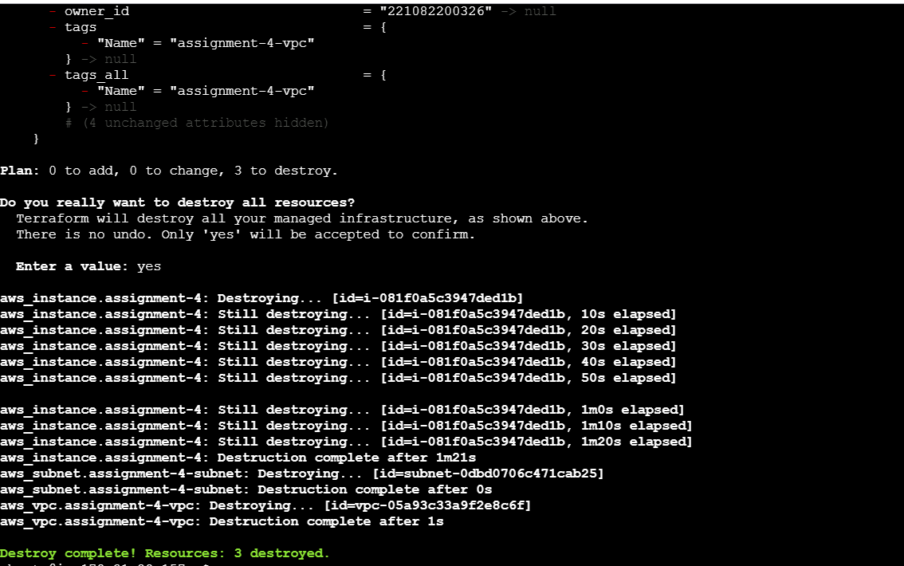

● Create a script to install apache2

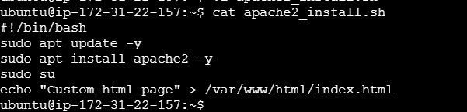

● Run this script on a newly created EC2 instance

● Print the IP address of the instance in a file on the local, once deployed

Terraform init

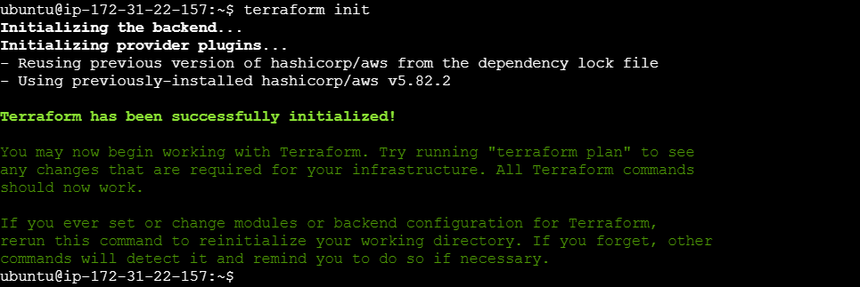

Terraform plan

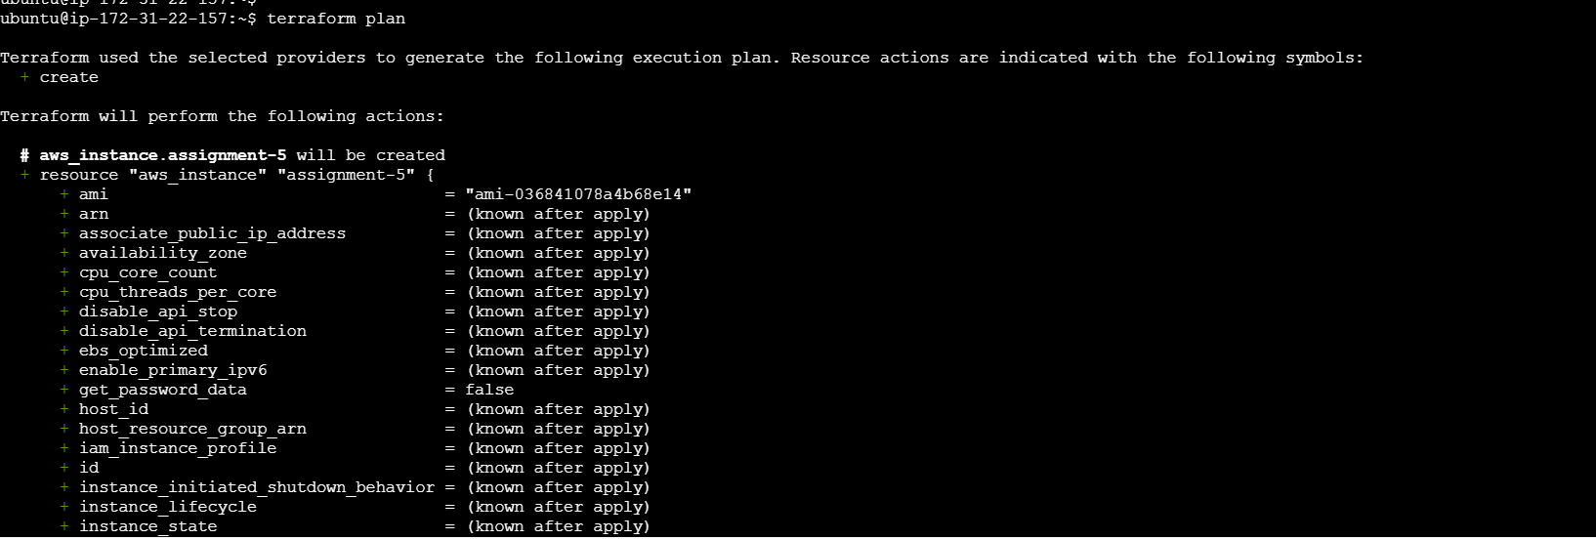

Terraform apply

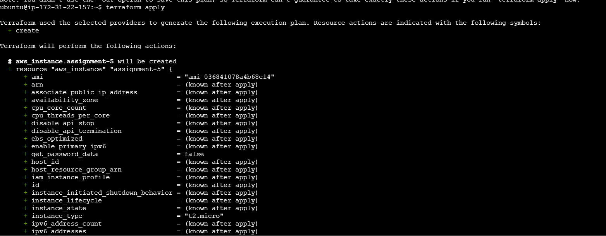

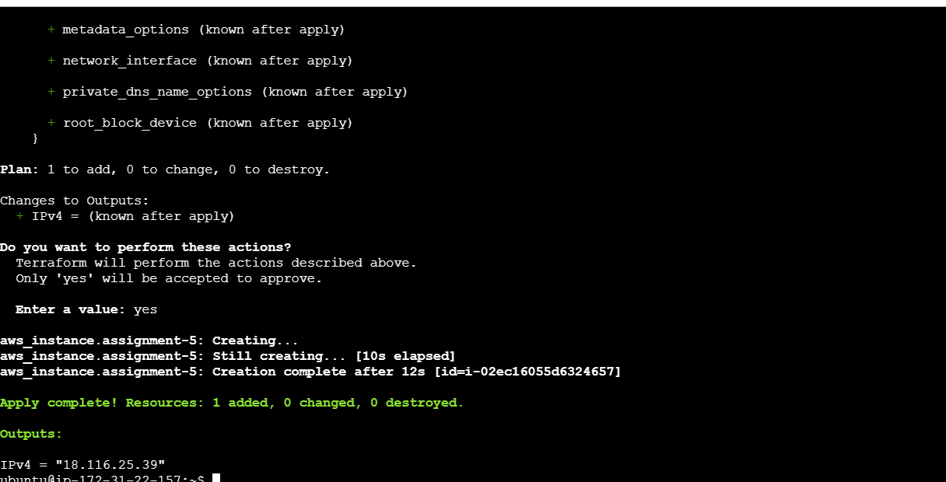

Take IP address it shows the custom msg

